

Use Case Specification: LSA eCL Submission
For
eCoaching Log

Change History Log

Date | Version | Description | Author
10/21/2014 | 1.0 | Initial Document | Doug Stearns
01/20/2015 | 1.1 | P14139 – eCL LSA Submission job codes  Updated 7.1 for additional submission job codes | Doug Stearns
02/05/2015 | 1.2 | P14252 – eCL LSA Job Codes to submit  Updated 7.1 for WISA12 – Administrator, Systems | Doug Stearns

Table of Contents

1. Brief Description 6
2. Participating Actors 6
2.1 Primary 6
2.2 Secondary 6
3. Basic Flow of Events 7
3.1 Identify coachable event. 7
3.2 Access eCoaching Log website submission page. 7
3.3 Select LSA module. 7
3.4 Select the appropriate LSA (required selection). 7
3.5 Program is not available, however default to NA. 7
3.6 Select the coaching delivery option (required selection). Select Yes to deliver coaching. 7
3.7 Progressive Disciplinary Warning is not available, however default to No. 7
3.8 Enter or select the date of coaching (required selection). 7
3.9 Customer Service Escalation is not available, however default to No. 7
3.10 Select applicable coaching reasons, whether opportunity or reinforcement, and applicable sub-coaching reasons (required selection) 7
3.11 Enter details of the behavior to be coached (required entry; free form text up to 3000 characters). 8
3.12 Enter details from the coaching session including action plans developed (required entry; free form text up to 3000 characters). Note: Yes selected in 3.6 (not available if No selected). 8
3.13 Select how the coaching opportunity was identified (required selection). 8
3.14 Call Record is not available, however default to No. 8
3.15 Select to verify that all information on the form is true and complete (required selection). 8
3.16 Submit the LSA eCoaching Log. 8
3.17 System generates eCoaching eMail notification. 8
3.18 Employee (LSA) receives system generated eMail notification of eCoaching Log when coaching is Direct and status is Pending Employee Review, then the eMail notification will use the following. 8
3.19 Employee (LSA) selects hyper link to eCoaching Log Dashboard. 9
3.20 Employee (LSA) uses eCoaching Log Dashboard to review and acknowledge logs. 9
4. Alternative Flows 10
4.1 Select the coaching delivery option. [Step 3.6] 10
5. Preconditions 10
5.1 eCoaching Log website available. 10
5.2 eCoaching Log database available. 10
5.3 eCoaching Log database populated with correct and current hierarchy information for Local Systems Administrators, LSA Mangers and Desktop Manager. 10
6. Postconditions 10
6.1 eCoaching Log submitted. 10
6.2 eMail notifications sent appropriately. 10
7. Assumptions and Dependencies 10
7.1 Access to LSA module will be limited to those with the following job codes: 10
8. Business Rules 10
8.1 none 10
9. Technical Requirements 10
9.1 none 10
10. Activity Diagrams 11

Table of Figures
Figure 1 – LSA eCL Submission 10

Brief Description
Allow eCoaching Logs for call center Local System Administrators.

Participating Actors

Primary

Local System Administrators (LSA)

LSA Managers

Secondary

Desktop Manager

Basic Flow of Events

Identify coachable event.

Access eCoaching Log website submission page.

Select LSA module.

Select the appropriate LSA (required selection).

Employees displayed will be those LSAs with job codes of WIHD01, WIHD02, WIHD03, WIHD04.

Program is not available, however default to NA.

Select the coaching delivery option (required selection). Select Yes to deliver coaching.

Possible options are:
Yes, I will be delivering the coaching session
No, I will not be delivering the coaching session

Progressive Disciplinary Warning is not available, however default to No.

Enter or select the date of coaching (required selection).

Customer Service Escalation is not available, however default to No.

Select applicable coaching reasons, whether opportunity or reinforcement, and applicable sub-coaching reasons (required selection)

Possible options are:
Coaching Reason | Opportunity and Reinforcement
- Sub-Coaching Reason
Attendance | Opportunity and Reinforcement
- Other: Specify reason under coaching details.
Corporate / Program Initiatives | Opportunity and Reinforcement
- Required Training
- Other: Specify reason under coaching details.
Professional Conduct | Opportunity and Reinforcement
- HR Guidelines
- Other: Specify reason under coaching details.
Quality | Opportunity and Reinforcement
- Acct Management
- Communication
- DCF
- Feedback
- Special Assign
- Other: Specify reason under coaching details.
Recognition | Reinforcement
- Kudos
- LSA Certification
- Other: Specify reason under coaching details.
Secure Floor Violations | Opportunity and Reinforcement
- CoR
- Other: Specify reason under coaching details.
Weekly Productivity | Opportunity and Reinforcement
- DCF Coverage
- Email Coverage
- Feedback
- Floor walking
- Side-by-Side
- Other: Specify reason under coaching details.

Enter details of the behavior to be coached (required entry; free form text up to 3000 characters).

Enter details from the coaching session including action plans developed (required entry; free form text up to 3000 characters). Note: Yes selected in 3.6 (not available if No selected).

Select how the coaching opportunity was identified (required selection).

Possible options are:
CMS Contractor (NGS, VCS) Reported Issue
CMS Reported Issue
Integrated Performance Center
Manager Coaching
Walk-By

Call Record is not available, however default to No.

Select to verify that all information on the form is true and complete (required selection).

Submit the LSA eCoaching Log.

System generates eCoaching eMail notification.

Employee (LSA) receives system generated eMail notification of eCoaching Log when coaching is Direct and status is Pending Employee Review, then the eMail notification will use the following.

Subject:
eCL: Pending Employee Review (<EMPLOYEE NAME>)
Message:
A new eCoaching Log has been entered on your behalf. Please click on the link below to review and verify the coaching opportunity received on <DATE>.

Employee (LSA) selects hyper link to eCoaching Log Dashboard.

Employee (LSA) uses eCoaching Log Dashboard to review and acknowledge logs.

Alternative Flows

Select the coaching delivery option. [Step 3.6]

Select No to not deliver coaching session.

Continue with steps 3.7 through 3.11 above, skip 3.12.

Continue with Step 3.13 above.

Pending Supervisor Review. [Step 3.18]

LSA Manager (receives system generated eMail notification of eCoaching Log when coaching is Indirect and status is Pending Supervisor Review then the eMail notification will use the following:.

Subject:
eCL: Pending Supervisor Review (<EMPLOYEE NAME>)
Message:
A new eCoaching Log has been entered on behalf of <EMPLOYEE NAME> on <DATE> that requires your action. Please click on the link below to review the eCoaching log.

LSA Manager selects hyper link to eCoaching Log Dashboard.

LSA Manager uses eCoaching Log Dashboard to review coaching logs.

Preconditions

eCoaching Log website available.

eCoaching Log database available.

eCoaching Log database populated with correct and current hierarchy information for Local Systems Administrators, LSA Mangers and Desktop Manager.

Postconditions

eCoaching Log submitted.

eMail notifications sent appropriately.

Assumptions and Dependencies

Access to LSA module will be limited to those with the following job codes:
LSA | WIHD01, WIHD02, WIHD03, WIHD04
LSA Manager | WMPR40, WMPR50
Desktop Manager | WPPM60
Others | WPPT40 – Supervisor, Project/Task  WPPT50 – Manager, Project/Task  WPPT60 – Sr Manager, Project/Task  WISA12 – Administrator, Systems

Basic from of eMail notification is as follows:

To – [strto]
Subject – [strSubject]
** This is an automated email. Do not reply to this email. **
[strCtrMessage]
Please click here to open the coaching application and select the 'My Dashboard' tab to view the below form ID for details. [Link to Dashboard]
Form ID: [strFormID]
(Please do not respond to this automated notification)
Thank you,
eCoaching Log Team


Business Rules

none

Technical Requirements

none

Activity Diagrams
Below is the activity diagram for the use case that provides a visual depiction of the flow of events.

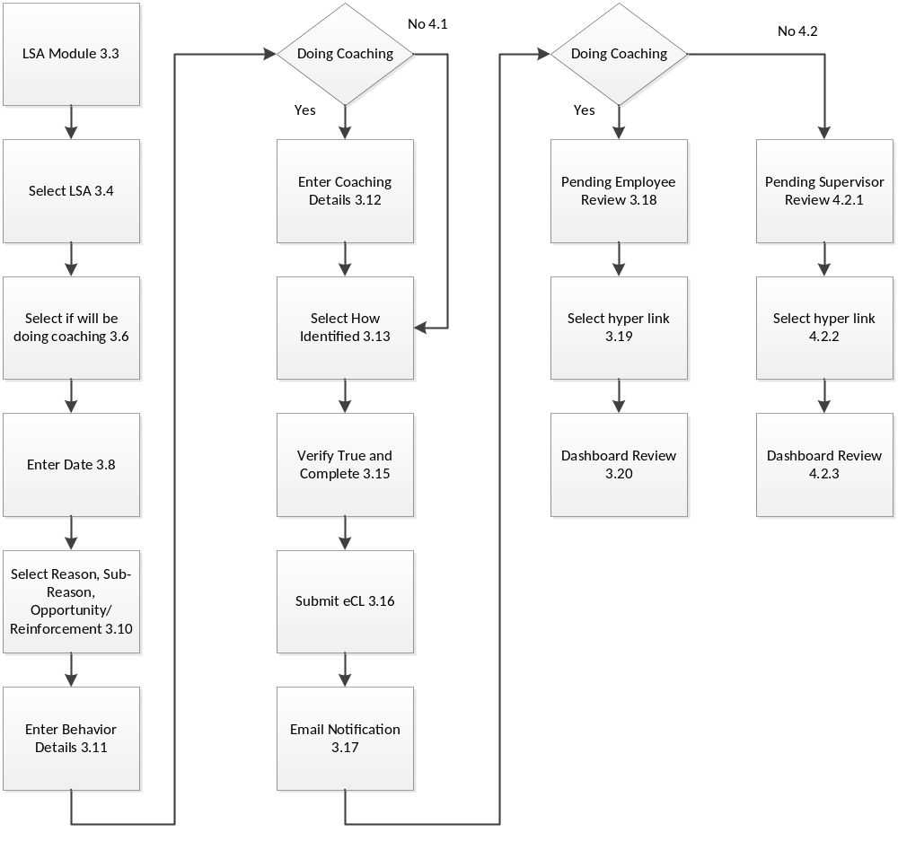

Figure 1 – LSA eCL Submission

